From: https://www.zerohedge.com/markets/deep-ship-deep-dive-supply-chain-crisis

Tidal Wave of Politics (Container 3 of 6)
Against this backdrop, is it any surprise that a tsunami of politics could soon sweep over global shipping?
In July, US President Biden introduced Executive Order 14036, “Promoting Competition in the American Economy”. This puts forward initiatives for federal agencies to establish policies to address corporate consolidation and decreased competition - which will include shipping. Ironically, the US encouraged “Too Big to Sail” for decades, but real and political tides both turn.
Indeed, in August a bipartisan bill was introduced in Congress --“The Ocean Shipping Reform Act of 2021”-- which proposes radical changes to:
- Establish reciprocal trade to promote US exports as part of the Federal Maritime Commission’s (FMC) mission;
- Require ocean carriers to adhere to minimum service standards that meet the public interest, reflecting best practices in the global shipping industry;
- Require ocean carriers or marine terminal operators to certify that any late fees --known in maritime parlance as “detention and demurrage” charges-- comply with [United States] federal regulations or face penalties;
- Potentially eliminate “demurrage” charges for importers;
- Prohibit ocean carriers from declining opportunities for US exports unreasonably, as determined by the FMC in new required rulemaking;
- Require ocean common carriers to report to the FMC each calendar quarter on total import/export tonnage and TEUs (loaded/empty) per vessel that makes port in the US; and
- Authorizes the FMC to self-initiate investigations of ocean common carrier’s business practices and apply enforcement measures, as appropriate.
Promoting reciprocal US trade would either slow global trade flows dramatically and/or force more US goods production. While that would help address the global container imbalance, it would also unbalance our economic and financial architecture. Fining carriers who refuse to pick up US exports would also rock many boats.
Moreover, forcing carriers to carry the cost of demurrage would change shipping market dynamics hugely. At the moment, the profits of the shipping snarl sit with carriers and ports, and the rising costs with importers: the US wants to reverse that status quo.
While global carriers and US ports obviously say this bill is “doomed to fail”, and will promote a “protectionist race to the bottom”, it is bipartisan, and has been endorsed by a large number of US organisations, agricultural producers and retailers.
Even smaller global players are responding similarly. For example, Thailand is considering re-launching a national shipping carrier to help support its economic growth: will others follow suite ahead?
Meanwhile, shipping will also be impacted by another political decision - the planned green energy transition. The EU will tax carbon in shipping from 2023, and new vessels will need to be built. For what presumed global trade map, as we just asked?
The green transition will also see a huge increase in the demand for resources such as cobalt, lithium, and rare earths. Economies that lack these, e.g., Japan and the EU, will need to import them from locations such as Africa and Australia. That will require new infrastructure, new ports, and new shipping routes – which is also geopolitical.
Indeed, the US, China, the EU, UK, and Japan have all made clear that they wish to hold commanding positions in new green value chains - yet not all will be able to do so if resources are limited. Therefore, green shipping threatens to be a zero-sum game akin to the 19th century scramble for resources. As Foreign Affairs noted back in July: “Electricity is the new oil” – meant in terms of ugly power politics, not more beautiful power production.
Before the green transition, energy prices are soaring (see our “Gasflation” report). On one hand, this may lift bulk shipping rates; on another, we again see the need for resilient supply chains, in which shipping plays a key role.
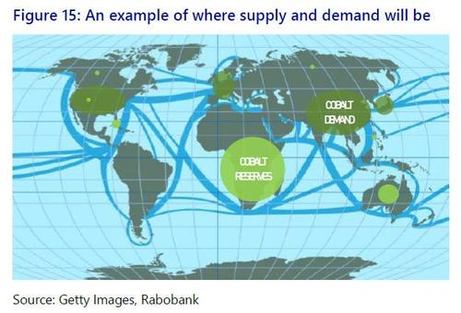
In short, current zero-sum supply-chains snarls, already seeing a growing backlash, are soon likely to be matched [accompanied?] by a zero-sum shift to new green industrial technologies and related raw materials. In both dimensions, shipping will become as (geo)political as it is logistical.
Notably, while tides may be turning, we can’t ‘just’ reshape the global shipping system, or get from “just in time” to “just in case”, or to a more localized “just for me” just like that: it will just get [more] messy in the process.

